APPENDIX A
PHOTOGRAPHS TAKEN DURING JIV AT 18” OBAMA/BRASS PIPELINE AT ONI-BUGO COMMUNITY, NEMBE L.G.A, BAYELSA STATE ON 26TH JUNE, 2024.
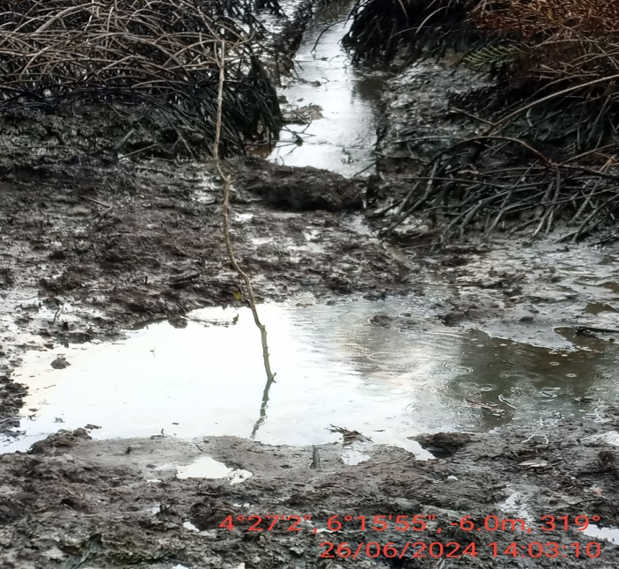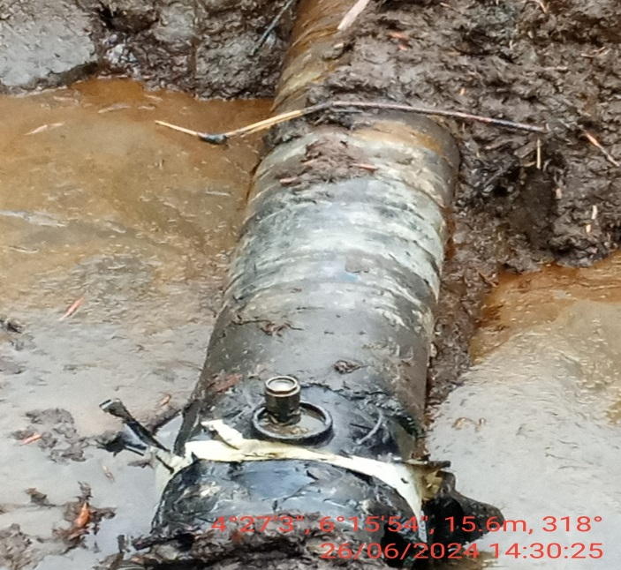
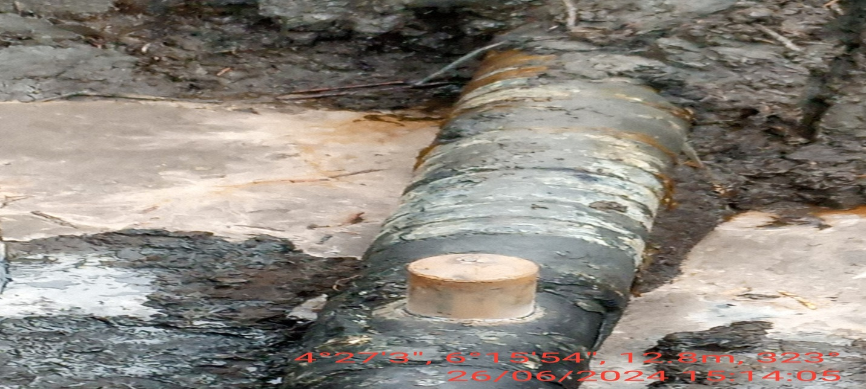
FIG.1:(L-R) THE INCIDENT POINT BEFORE EXCAVATION.
FIG.2: 2” VALVE RE-INSTALLED AT 12 O’ CLOCK POSITION OF THE PIPELINE FOR POSSIBLE CRUDE OIL THEFT ACTIVITY BY VANDALS AFTER CUTTING OFF PREVIOUSLY CONED POINT.
FIG.3: THE INCIDENT POINT AFTER REPAIRS.

